VE311 Lab 3

Weikai Zhou 518021911039

1. **Common-Source with Source Degradation Amplifier**
2. In this part, we first build the circuit below (Figure 1) in Proteus. Our group chose $R_{D}=68 kΩ$, $R_{S}=8kΩ$.

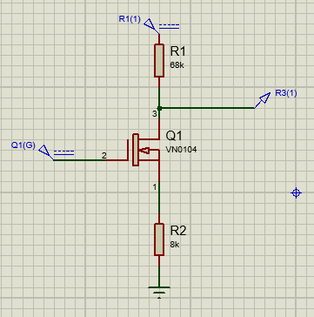

Figure 1. Proteus circuit

Then, we use DC sweep in Proteus to get $V_{OUT}$ vs $V_{IN}$ (Figure 2).

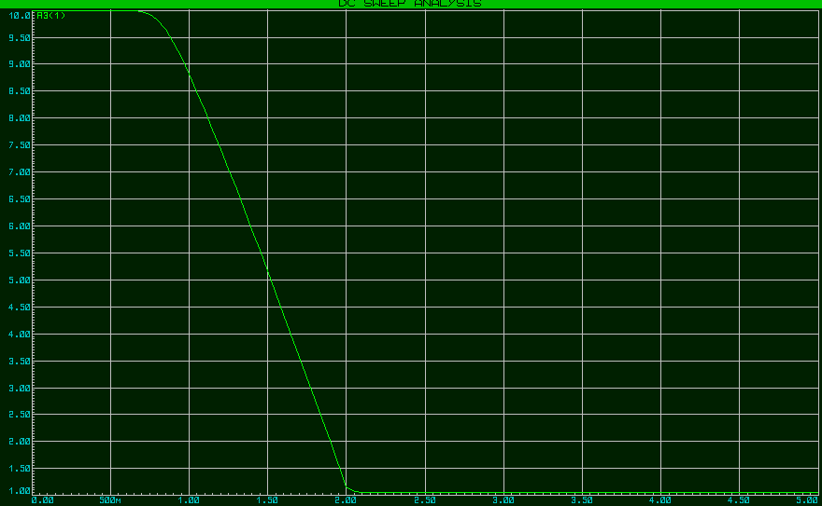

Figure 2. DC sweep

From the figure, we can get (1.49, 5.24), (1.51, 5.08), and we can get

$$\left|{slope}_{1.5}\right|=\left|\frac{5.08-5.24}{1.51-1.49}\right|=8>5.$$

And the result is close to $R_{D}$/ $D_{S}$ = 68/8 = 8.5.

In lab, we get the following data (Table 1).

|  |  |
| --- | --- |
| $V_{IN}$ (V) | $V_{OUT}$ (V) |
| 0.1 | 9.950 |
| 0.5 | 6.600 |
| 0.6 | 5.020 |
| 0.7 | 3.420 |
| 0.8 | 1.805 |
| 0.9 | 1.247 |
| 1.0 | 1.421 |
| 1.5 | 2.380 |
| 2.0 | 3.362 |

Table 1. Measurement result

And we can get the following plot (Figure 3).

Figure 3. $V_{OUT}$ vs $V_{IN}$ for measurement result

We can calculate the absolute value of slope at 0.8 as

$$\left|{slope}_{0.8}\right|=\left|\frac{1.805-3.42}{0.8-0.7}\right|=16.15.$$

The value we get in lab is about two times of the $R_{D}$/ $D_{S}$ = 68/8 = 8.5. The reasons for this may be that the NMOS and the resistor we used in lab are different from those we used in Proteus. Besides, the inner resistance may also cause it.

1. In this case, we use $V_{in}=1.5+0.01sin(2π{10}^{2}∙time)$. In Proteus, we can get the following figure (Figure 4).

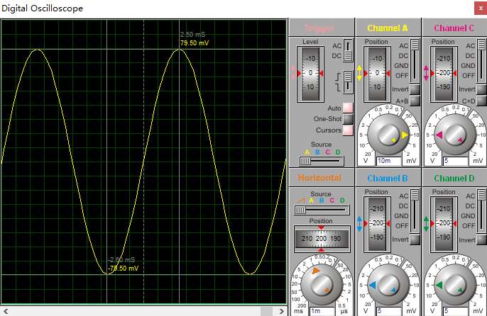

Figure 4. Simulation result

From the cursor, we can get

$$v_{out}=\frac{0.0795+0.0785}{2}=0.079 V.$$

Also, from **(a)**, we can get

$$0.01×A_{v}=0.01×8=0.08.$$

They are very close, so we can confirm that the amplitude of $v_{out}$ is equal to $0.01×A_{v}$.

In the lab, we use $V_{in}=0.8+0.01sin(2π{10}^{2}∙time)$ and get the following figure (Figure 5).

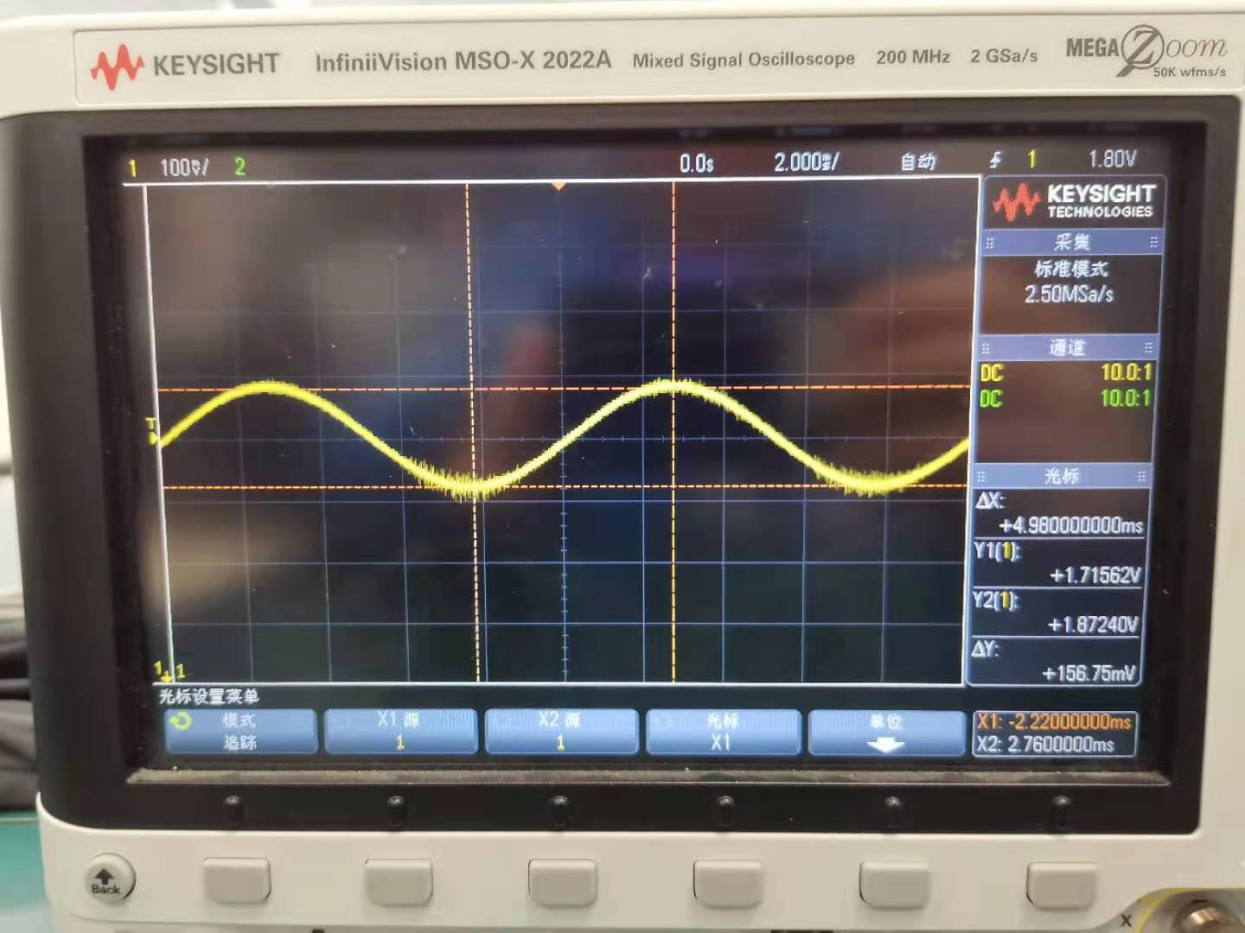

Figure 5. Measurement result for $0.8+0.01sin(2π{10}^{2}∙time)$

We can get that $v_{out}=$ 0.078375 V. However, it is smaller than $0.01×A_{v}=0.01×16.15=0.1615$. It may be because that there may be some problem with the circuit we built.

1. We change the circuit to the figure below (Figure 6). Our group chose $R_{L}=68 kΩ$.

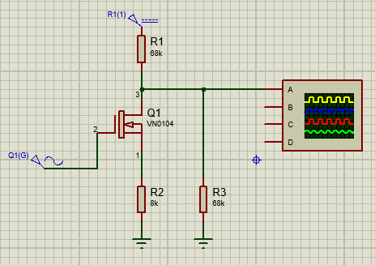

Figure 6. Proteus circuit

We use $V_{in}=1.5+0.01sin(2π{10}^{2}∙time)$. In Proteus, we can get the following figure (Figure 7).

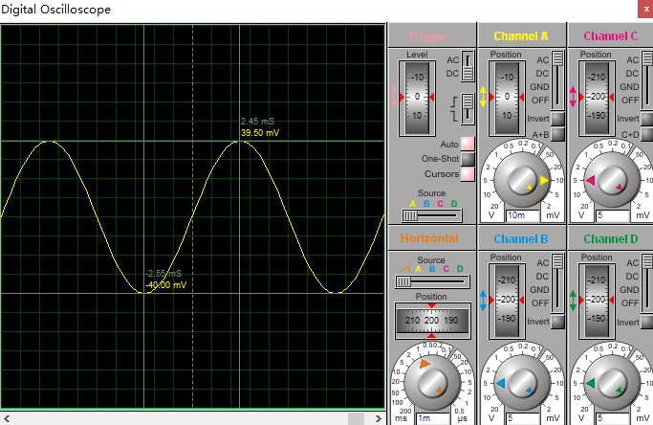

Figure 7. Simulation result

From the cursor, we can get

$$v_{out}=\frac{0.0395+0.040}{2}=0.03975 V,$$

which is smaller than

$$0.01×A_{v}=0.01×8=0.08.$$

In lab, we use $V_{in}=0.8+0.01sin(2π{10}^{2}∙time)$ and get the following figure (Figure 8).

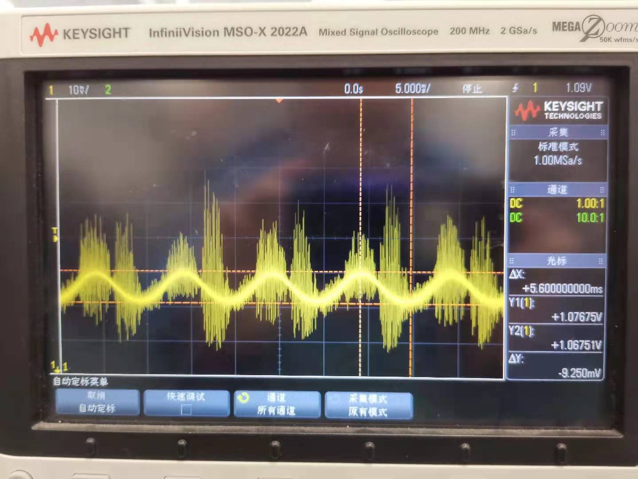

Figure 8. Measurement result

We get that $v_{out}=0.004625$ V. It is smaller than $0.01×A_{v}$. The reasons for it smaller than $0.01×A_{v}$ may be that in small signal circuit, $R_{L}$ is in parallel with $R_{D}$, so $(R_{L}|\left|R_{D}\right)<68 kΩ$. Also, $A_{v}=G_{m}R_{out}$. In this case $G_{m}$ does not change but $R_{out}$ becomes small. Therefore, after connecting $R_{L}$, the circuit has a new $A_{v}$ which is smaller than the original one. Therefore, $v_{out}$ becomes smaller.

1. **Source follower**
2. In this part, we first build the circuit below (Figure 9) in Proteus. Our group chose $R_{S}=470Ω$.

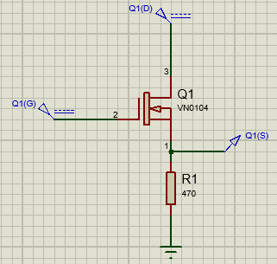

Figure 9. Proteus circuit

Then, we use DC sweep in Proteus to get $V_{OUT}$ vs $V_{IN}$ (Figure 10).

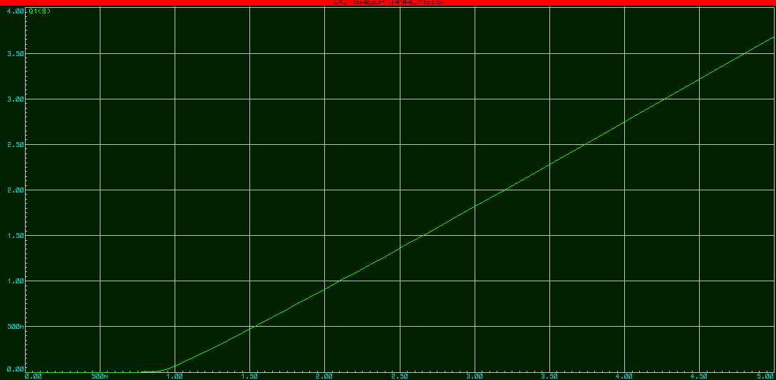

Figure 10. DC sweep

From the figure, we can get (2.99, 1.81), (3.01, 1.83), and we can get

$$\left|{slope}_{3}\right|=\left|\frac{1.83-1.81}{3.01-2.99}\right|=1>0.5.$$

We can see that the voltage gain is very close to the unity.

In lab, we get the following data (Table 2).

|  |  |
| --- | --- |
| $V_{IN}$ (V) | $V_{OUT}$ (V) |
| 0.1 | 1.444 |
| 0.5 | 1.860 |
| 0.6 | 1.970 |
| 0.7 | 2.090 |
| 0.8 | 2.204 |
| 0.9 | 2.323 |
| 1.0 | 2.440 |
| 1.5 | 3.070 |
| 2.0 | 3.837 |

Table 2. Measurement result

And we can get the following plot (Figure 11).

Figure 11. $V_{OUT}$ vs $V_{IN}$ for measurement result

We can calculate the value of slope at 0.8 as

$$\left|{slope}_{0.8}\right|=\left|\frac{2.204-2.090}{0.8-0.7}\right|=1.14>0.5.$$

And it is close to the unity.

1. In this case, we use $V_{in}=3+0.05sin(2π{10}^{2}∙time)$. In Proteus, we can get the following figure (Figure 12).

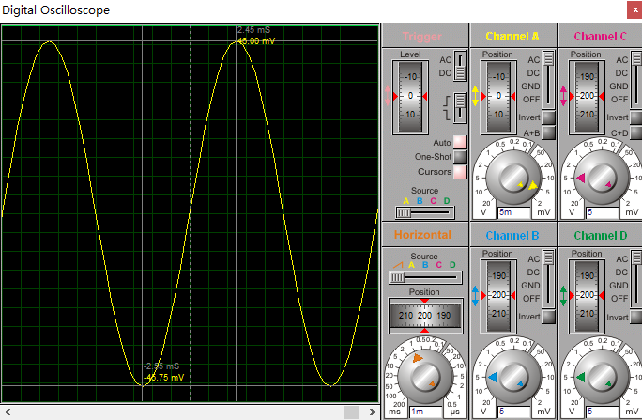

Figure 12. Simulation result

From the cursor, we can get that

$$v_{out}=\frac{0.046+0.04575}{2}=0.045875 V.$$

Also, from **(a)**, we have

$$0.05×A_{v}=0.05×1=0.05.$$

They are very close, so we may conclude that the amplitude of $v_{out}$ is equal to $0.05×A_{v}$.

In lab, we use $V_{in}=0.8+0.05\sin\left(2π{10}^{2}·time\right)$, and get the following figure (Figure 13).

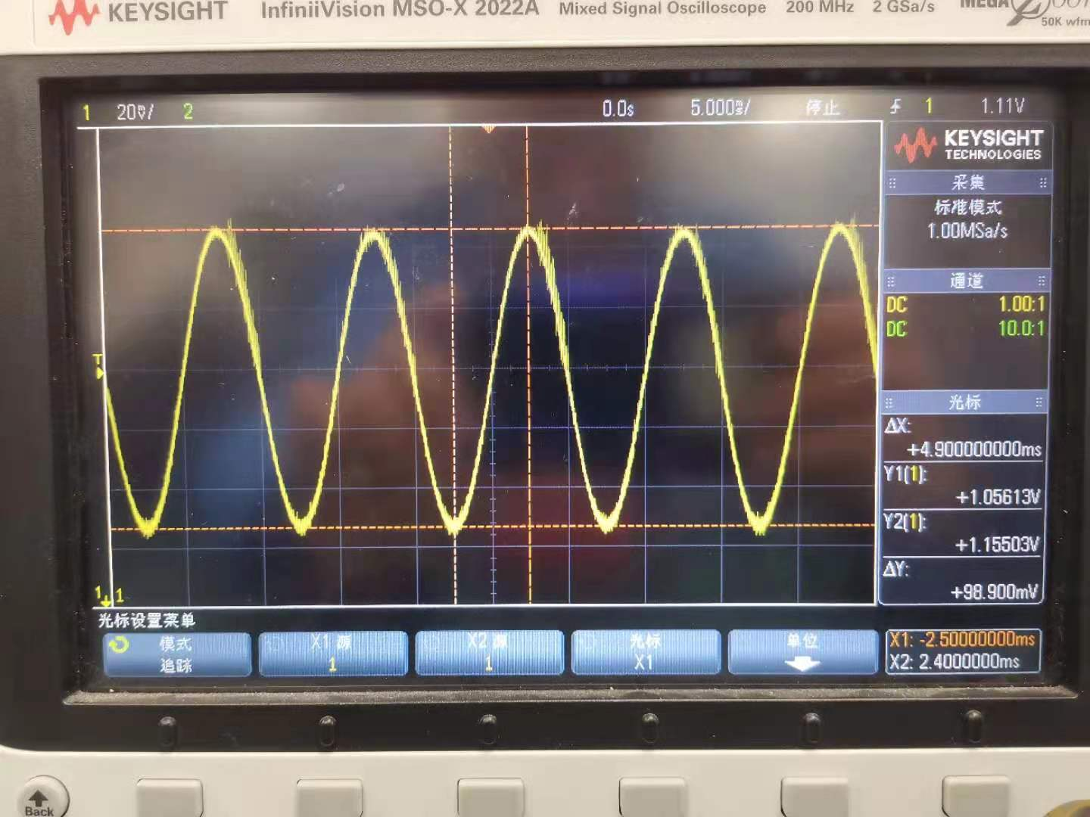

Figure 13. Measurement result for $V_{in}=0.8+0.05\sin\left(2π{10}^{2}·time\right)$

We can get that $v_{out}=0.04945$ V. It is very close to $0.05×A_{v}$. Therefore, we may conclude that the amplitude of $v_{out}$ is equal to $0.05×A_{v}$.

1. We change the circuit to the figure below (Figure 14). Our group chose $R_{L}=68 kΩ$.

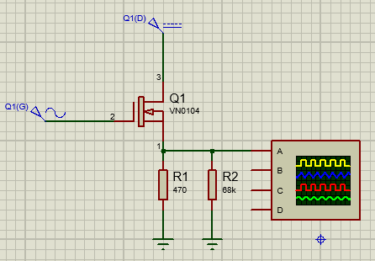

Figure 14. Proteus circuit

We use $V_{in}=3+0.05sin(2π{10}^{2}∙time)$. In Proteus, we can get the following figure (Figure 15).

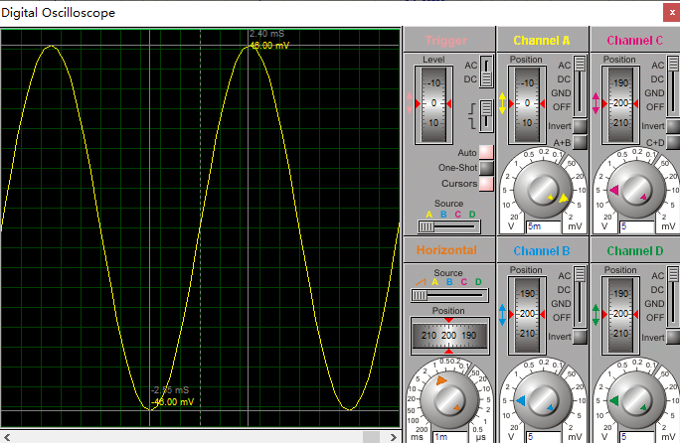

Figure 15. Simulation result

From the cursor, we can get that

$$v_{out}=\frac{0.046+0.046}{2}=0.046 V.$$

We can see that it is still around $0.05×A_{v}$. Because $R_{L}$ is significantly larger than $R_{S}$, so $(R_{S}||R_{L})≈R_{S}$. Therefore, after adding $R_{L}$, $v_{out}$ will not change much.

In lab, we use $V_{in}=0.8+0.05\sin\left(2π{10}^{2}·time\right)$, and get the following figure (Figure 16).

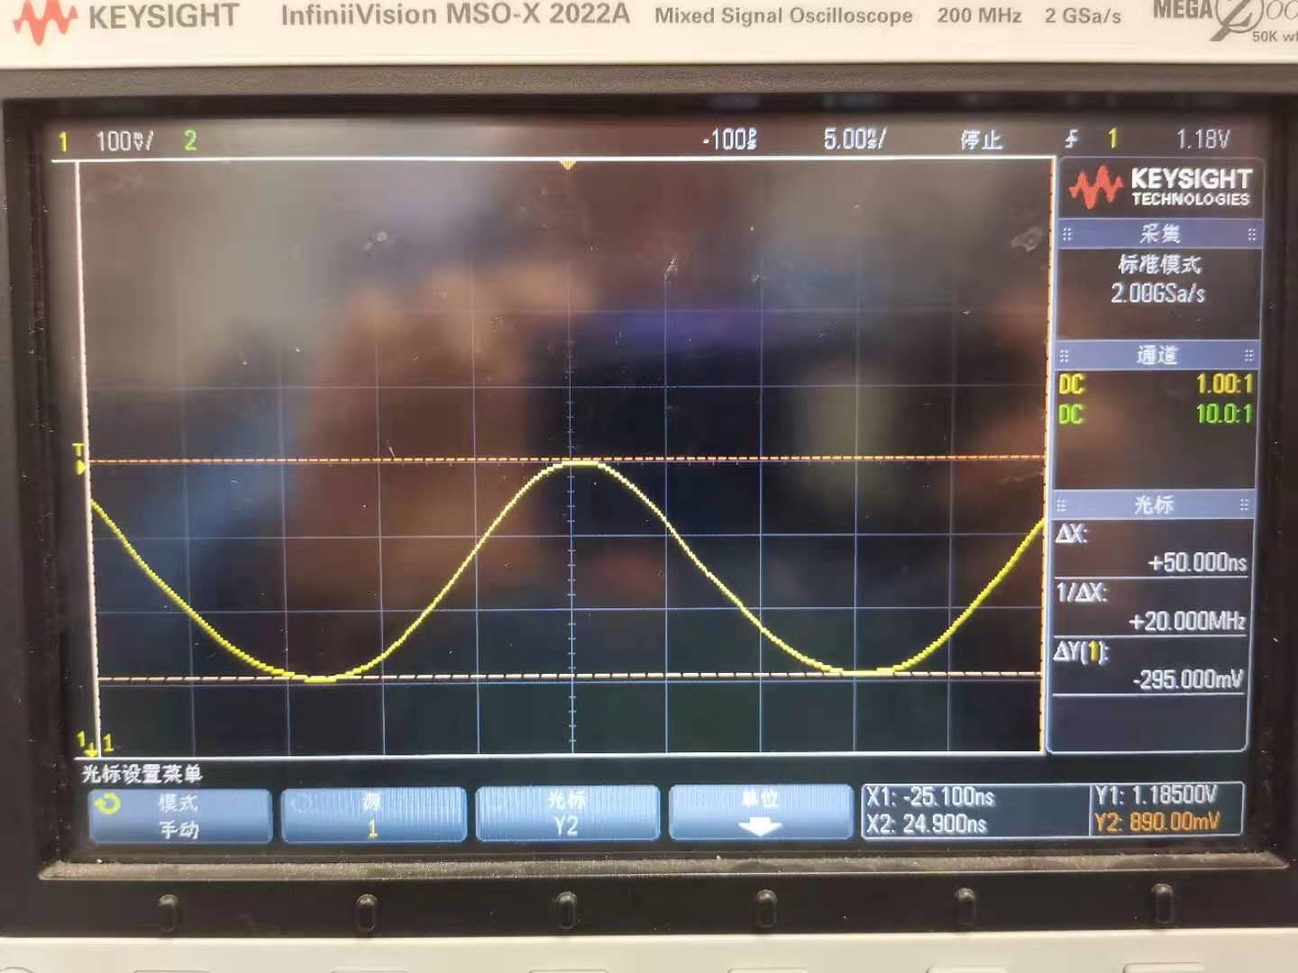

Figure 16. Measurement result for $V_{in}=0.8+0.05\sin\left(2π{10}^{2}·time\right)$

We can get that $v_{out}=0.1475$ V. However, it is not close to $0.01×A_{v}$. It may be because that the NMOS and the resistor we use in lab are different from those used in Proteus. Besides, the inner resistance of the circuit may also lead to it.